Name: _____________________
“WATER” UNIT 1 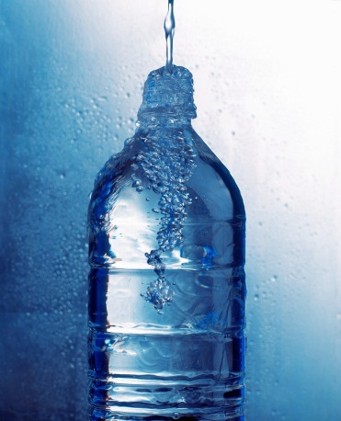
Deconstruction and Reconstruction

- _____ 20 pts. 9/1-3 7. Portfolio Grade - _____ 10/10
- _____ 50 pts. 8. Presentation Grade - _____ 10/22
- _____ 50 pts. 9/22-23 9. Reading Unit 2 Book - _____ 10/15
- _____ 20 pts. 9/15-17 11. Essay Grade - _____ 11/3
- _____ 20 pts.
- _____ 100 pts. 10/13-16
10. _____ 30 pts. 10/15
Extra Credit _____

Message to the Instructor - _________________

Items 1,2,3,4,5,6,9, and 10 are graded as the research and reading unit and will compose one grade.

390 x .26 = _____ Research and Reading Grade Due – 11/29

Items 7, 8, 9, and 11 will all be separate grades and count equally with the Research and Reading Grade.

1. Video: Blue Gold Video – 2 day
Watch the video and list topics for possible research. Class discussion will assist in the making of questions for the possible research for essay and presentation. This will be a group assignment and all will work together. 20 pts. (3)

2. Videos. Select five videos on the research topic you selected. Write the URL and then a one paragraph summary of each video. Select the best video and deconstruct. List the thesis or question. List three reasons given by the author. List the conclusion. Include the counterargument if there is one. 50 pts. (3)

3. Deconstruction. Select an article or webpage on your specific issue. Deconstruct the article by copying and pasting the article then using the labeling rubric.
Select a second article and validate the author and the content. Write one sentence about the strengths and weaknesses of the author and one about the content. You are explaining why the article is useful research and reliable. The student will choose a partner and they will peer review and revise each student’s work. The finished product will be turned in. 50 pts. (3)

4. Video: Bottled or Tapped – 2 day
Watch the video and list topics for possible research topics and a practice on question writing. Each student must develop five good questions. Students will list form a group of five students and discuss the question wording and topics. They will work together and select the five best and turn them in. 20 pts. (4)
5. Global Perspective. Go to the UN website, un.org. and research the UN stand on water as a human right. List ten facts that will help support your question. OR Do the same for another NGO that is pertinent to your question. 20 pts. (1)
6. Outline the topic. State your question for this unit, state the thesis, 2 reasons to support the thesis, 2 reasons that represent the opposition, 2 examples for each side, 4 source validations (one sentence each), and 3 sentences of reflection. Remember the question and research must be global. 100 pts. (5)
7. Create a portfolio of material to support your presentation and essay. The portfolio must have 1 annotated bibliography (with ten sources), 3 charts or graphs, 3 videos, 2 articles for each side. 100 pts. (5)
8. Present your thesis. The presentation should have two reasons you believe will support it. Then empathize with the opposition with two reasons to support the other side. State a conclusion restating all the reasons for both sides. The presentation should be accompanied by five to ten images, charts, graphs, title with thesis and reasons slide. The presentation should be 3 to 5 minutes. The presentation needs to have a transcript. This assignment will be done with a partner. The partner will peer review the presentation and your materials. The partner will also preview the presentation and then tape it with your phone or the camera. The presentation will be viewed and graded by two other teams. 100 pts. (5-2)
9. Read the Book. The student will have selected the book to read for the next unit. (Tomatoland, Food Justice, Banana, or Cod) The student will need to read 50% of the book by the end of the unit. The student will be graded on highlighting, and note taking if using the Kindle. This can be graded on the Kindle. The student needs to write at least 10 notes per chapter and 10 highlights per chapter. If the student is using the text the student needs to tab 10 places in each chapter and list ten facts per chapter. 100 pts. (10)
10. Book Test. The student will take a test on the book they are reading. 30 pts.
11. Essay. The student will write a 1500 to 2000 word essay on their question. The student will write the essay at home but can receive assistance from the instructor during the process. Do not wait to the last minute!!!!!!!!!! This cannot be done in one night successfully. 100 pts. (3)
Deconstruction Rubric
R – Reasons
E – Examples
T – Thesis
CA – Counter thesis
F1- Fallacies
F2 – Fallacies

Criteria of Credibility (RAVEN)
R – Reputation (Does the source’s history or status suggest reliability or unreliability?
A – Ability to See (Is the source in a position to know what they’re talking about? Can their observations be trusted?)
V – Vested Interest (Has the source of information anything personally at stake?)
E – Expertise (Does the source have specialized knowledge and does the situation demand it?)
N – Neutrality (Is the source predisposed to support a particular point of view for reasons other than vested interest?)

